Section 1: Case Summary

Scenario Title: | Hypothermic Cardiac Arrest
Keywords: | Cardiac Arrest, Hypothermia, Pre-hospital, ECLS, ECMO
Brief Description of Case: | A 24-year-old previously healthy male presents to the ED with absent vital signs. He is out for a trail run when he becomes trapped in waist deep cold water. When he is found by search and rescue, he is awake with altered mental status. He has a cardiac arrest on retrieval and is found to be severely hypothermic. CPR and ACLS is initiated and he is transferred to the nearest community ED. The resuscitation team is expected to perform ACLS specific to hypothermic arrest. The patient will require intubation, active rewarming, defibrillation and discussion with the ECMO physician on call for transport and ECMO assisted rewarming.

Goals and Objectives
Educational Goal: | Solidify specific approach to cardiac arrest in the hypothermic patient
Objectives:  (Medical and CRM) | 1. Use closed-loop communication and role assignment to effectively lead the team through the care of a cardiac arrest patient  2. Convey management priorities with team to achieve a shared mental model  3. Effectively communicate patient condition to consultant specialists  4. Consider a broad differential in your approach to cardiac arrest  5. Identify specific management steps for a hypothermic cardiac arrest patient  6. Consider indications for termination of resuscitation in a hypothermic patient
EPAs Assessed: | Core EPA: C1 Resuscitating and coordinating care for critically ill patients.

Learners, Setting and Personnel
Target Learners: | ☐ Junior Learners |  | ☒ Senior Learners |  |  | ☐ Staff
 | ☒ Physicians | ☒ Nurses |  | ☒ RTs | ☒ Inter-professional
 | ☐ Other Learners:
Location: | ☒ Sim Lab |  | ☒ In Situ |  |  | ☐ Other:
Recommended Number of Facilitators: | Instructors: 1
 | Sim Actors: Option to include two paramedics in the scenario
 | Sim Techs: 1

Scenario Development
Date of Development: | May 17, 2021
Scenario Developer(s): | Dr. Katie Maguire, Content Experts: Drs. Jan Trojanowski and Doug Brown
Affiliations/Institutions(s): | UBC
Contact E-mail: | k.maguire@alumni.ubc.ca
Last Revision Date:
Revised By:
Version Number:

Section 2A: Initial Patient Information

- Patient Chart
Patient Name: Eric |  |  |  | Age: 24 | Gender: M | Weight: 72 kg
Presenting complaint: Cardiac Arrest
Temp: 25°C (core) | HR: 0/min | BP: 0 |  | RR: 10 (vented) | O₂Sat: 87% | FiO₂: 100%  EtCO2: 8
Cap glucose: 6.0 |  |  |  | GCS: E1VTM1
Triage note:
24-year-old male previously healthy is brought in by search and rescue to your ED in cardiac arrest. He was found awake and cold in a ravine and subsequently lost his pulse.
Allergies: none
Past Medical History: none |  |  | Current Medications: none

Section 2B: Extra Patient Information
A. Further History
This information will be provided by the transporting paramedics.

24-year-old male previously healthy went for a trail run 6 hours ago slipped off of a bridge into a creek at the bottom of a ravine. He was waist deep in cold water and unable to climb out. When he did not return home as expected, Search and Rescue (SAR) was notified.

They found him in water, holding onto a rock, conscious but altered. By SAR estimates, he was likely in the water for one hour.

SAR were able to safely retrieve him from the ravine. He lost consciousness as he was rescued and on reassessment had lost pulses. CPR was started immediately. Pads were placed and he received one shock for VF, that was unsuccessful. His rhythm degenerated to asystole. He received one dose of epinephrine 1mg after an IO was placed. An iGel was placed. His oral temperature at the scene was 24ºC . The SAR team were directed to transfer him to the nearest emergency department, a rural community hospital.

When the patient arrives, he remains in cardiac arrest after 45 minutes of CPR and two additional doses of IO epinephrine 1mg.
B. Physical Exam
List any pertinent positive and negative findings
Cardio: cold, central pulses palpable with ongoing CPR, no pulses at rhythm check | Neuro: GCS E1VTM1, pupils 6 mm and reactive
Resp: supraglottic intubation, crackles throughout bilaterally | Head & Neck: no signs of trauma
Abdo: soft, non-distended | MSK/skin: cool to touch
Other:

Section 3: Technical Requirements/Room Vision

A. Patient
☒ Mannequin (adult)
☐ Standardized Patient
☐ Task Trainer
☐ Hybrid
B. Special Equipment Required
Defibrillator and pads
EKG leads/wires
NIBP Cuff
Pulse oximeter
Esophageal/rectal temperature probe
Intubation supplies
Capnography
Bear Hugger
IV Bags/Lines
External mechanical CPR device (if available at your center)
C. Required Medications
ACLS medications

D. Moulage
N/A

E. Monitors at Case Onset
☐ Patient on monitor with vitals displayed
☒ Patient not yet on monitor
F. Patient Reactions and Exam
Include any relevant physical exam findings that require mannequin programming or cues from patient
(e.g. – abnormal breath sounds, moaning when RUQ palpated, etc.) May be helpful to frame in ABCDE format.
A – iGel supraglottic device in place
B – Mechanically ventilated, crackles bilaterally
C – Cool to touch, pulses palpable with chest compressions
D – E1VTM1, no sedation, pupils 6 mm and reactive
E – Temperature 25ºC esophageal/rectal probe, wet clothes have been removed, dry blankets cover patient

Section 4: Sim Actor and Standardized Patients

Sim Actor and Standardized Patient Roles and Scripts
Role | Description of role, expected behavior, and key moments to intervene/prompt learners. Include any script required (including conveying patient information if patient is unable)
Paramedic 1 | Gives additional history (this can be through the SIM facilitator if additional person not available). Please see additional information above. May ventilate the patient.
Paramedic 2 | Ongoing chest compressions until accepting team takes over, or LUCAS device is applied

Section 5: Scenario Progression

Scenario States, Modifiers and Triggers
Patient State/Vitals | Patient Status | Learner Actions, Modifiers & Triggers to Move to Next State |  | Facilitator Notes
1. Baseline State  Rhythm: VF  HR: 0/min  BP: 0/0  RR: 10/min  O₂SAT: 83% with CPR  T: 25ºC (core)  GCS: E1VTM1  EtCO2: 8 mmHg | Pt has supraglottic airway in situ, ongoing chest compressions | Expected Learner Actions  High quality CPR  Use CPR device if able  Monitors (incl core temp probe) and defibrillator pads  IV access + bloodwork  Hold epinephrine until >30ºC  After 3 defib attempts, hold rhythm checks until temp has increased by 2-4ºC  Amiodarone per ACLS  Minimally invasive active warming, external rewarming  Call nearest ECMO site lead  Point of care ultrasound  Capillary glucose | Modifiers  Changes to patient condition based on learner action  Triggers  For progression to next state  - Decision to intubate or 5 minutes elapsed | - prompt for esophageal/rectal probe if not done  - if not moving to next section, create sound of poor seal through iGel  - external and minimally invasive active warming includes warm IVF, forced warm air blankets, do not apply heat to head  - bedside echo shows ventricular fibrillation
2. Definitive airway  Rhythm: VF  HR: 0/min  BP: 0/0  RR: 10/min  O₂SAT: 70% with CPR  T: 26ºC  EtCO2: 8 mmHg | Sound of poor seal from iGel, desaturation | Expected Learner Actions  Airway plan communicated  No requirement for RSI drugs  Tube confirmed with EtCO2, misting, air entry, CXR ordered  Consider timing intubation with pulse check/bedside echo  Continued rewarming efforts | Modifiers  - intubated → O₂SAT: 90%  Triggers  - Discussion with ECMO consultant complete | - Labs given  - ECMO site lead calls once definitive airway confirmed. “Though ECMO is indicated, due to unavailable flight crews, patient is not accepted for transfer.”
3. Ongoing VF  Rhythm: VF  HR: 0/min  BP: 0/0  RR: 10 (vent)  O₂SAT: 90% with CPR  T: 29ºC  GCS: E1VTM1  EtCO2: 8 mmHg | Temperature increases | Expected Learner Actions  Increase rewarming efforts (warm ventilation, bladder irrigation)  Consider invasive rewarming (thoracostomy, dialysis)  Rhythm check based on temperature increase  Repeat point of care ultrasound during rhythm check  Defibrillation delivered appropriately | Modifiers  Triggers  - Defib at 29ºC → ROSC | - Prior to defibrillation bedside echo continues to show subtle fibrillations
4. ROSC  Rhythm: Bradycardia  HR: 35/min  BP: 80/54  RR: 10 (vent)  O₂SAT: 96%  T: 29ºC  GCS: E1VTM1  EtCO2: 25 mmHg | Patient achieves ROSC but is persistently hypotensive | Expected Learner Actions  Reassessment post ROSC  Warm fluid resus for hypotension  Avoid vasopressors  Initiate post ROSC care  Repeat labs, ECG, CXR  Call ICU if not previously involved | Modifiers  Triggers  - End case here or at 15 minutes | ECG and CXR given

Appendix A: Laboratory Results

CBC
WBC 10
Hgb 125
Plt 325

Lytes
Na 140
K 3.3
Urea 7
Cr 65
Glucose 6.0

VBG
pH 6.90
pCO₂ 47
HCO₃ 8
Lactate 12

Appendix B: ECGs, X-rays, Ultrasounds and Pictures

Ultrasound Video (Ventricular fibrillations): https://youtu.be/AW6v0nOhrkE

Post-ROSC ECG: https://litfl.com/hypothermia-ecg-library/
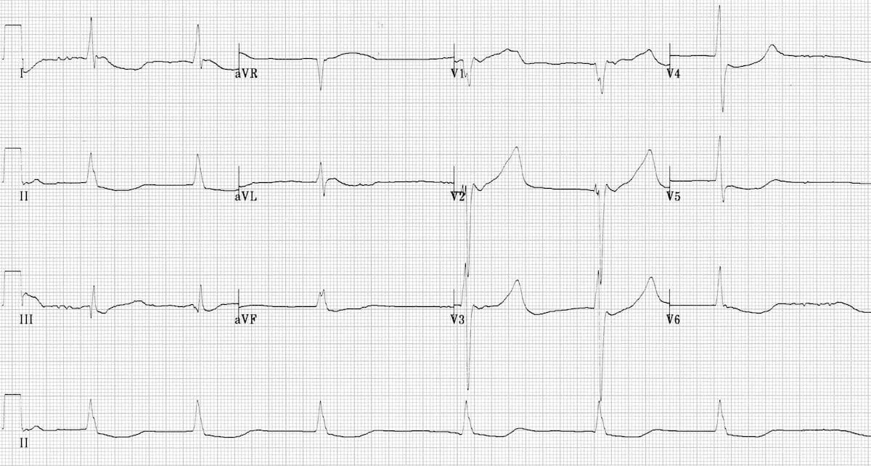

Chest X-ray: https://jetem.org/ettcxr/
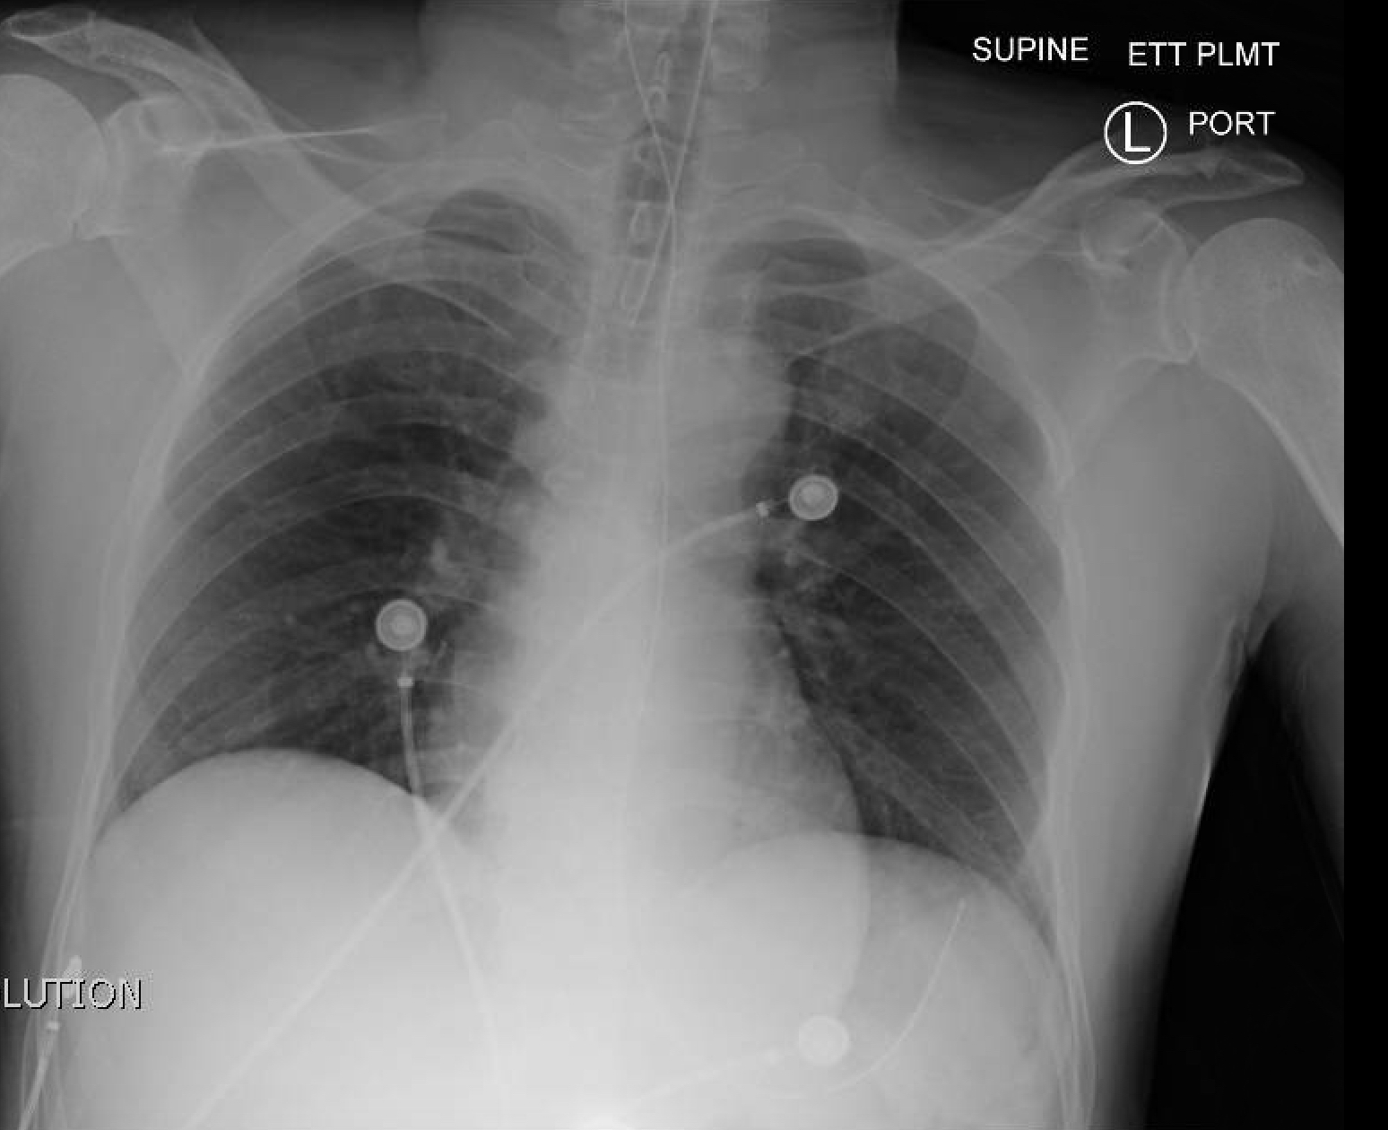

Appendix C: Facilitator Cheat Sheet & Debriefing Tips

Medical management questions (see cheat sheet below)
- Identify the changes in ACLS for the hypothermic cardiac arrest.
- Where is the recommended placement of temperature probe in a hypothermic patient?
- What are the indications for ECMO? What are some prognostic markers you can use?
- Why did the patient have a cardiac arrest after being rescued?
- How should we manage post ROSC hypotension in the hypothermic patient?
- How can potassium be used to determine if resuscitation should be continued on a hypothermic patient?

Crisis-resource management questions:
- How did the team handle this complex case?
- Was your whole team aware of the differences in management for hypothermic arrests? Do you feel that the differences in priorities were communicated?

Cheat Sheet:

- Identify the changes in ACLS for hypothermic cardiac arrest.
  - Diagnosis is critical. Hypothermic cardiac arrest patients should have no other obvious cause of death prior to cooling, a core temperature consistent with arrest, and absence of markers of death prior to cooling (see question 6).
  - Cardiac arrest is possible below 32°C, and is substantially more likely below 28°C.
  - In these patients, continuous CPR, total of three doses of epinephrine and defibrillation are indicated. In patients that do not respond to initial defibrillation and epinephrine therapies, do not pause CPR to analyze the rhythm until the core temperature has been increased by 2 – 4 °C.
  - Active external and minimally invasive rewarming includes warm environment, forced-air heating blankets, heating pad under the patient, warm parenteral fluids (38 - 42°C), +/- bladder lavage. You should avoid applying heat to head.

- Where is the recommended placement of temperature probe in a hypothermic patient?
  - In the intubated patient the lower third of the esophagus is the preferred site for a core temperature measurement. This is the most closely we can approximate the cardiac temperature. In patients that are not intubated, rectal or bladder probes are adequate, however, often lag behind the true core temperature. Measuring temperature using oral or tympanic measurements do not reflect the true core temperature and should be avoided.

- What are the indications for ECMO for warming? What are some prognostic markers you can use?
  - Consideration of ECMO for patients with HT III/IV (see figure 1 below). Barring contraindications, ECMO should be considered for patients with cardiac instability refractory to medical management, comorbid patient unlikely to tolerate poor cardiac output, or patients with absent vital signs. ECMO was indicated but unavailable for this patient. If ECMO was available, resuscitation goals would shift to high quality CPR, rapid transport, maintenance of core temperature (without further warming). Further ACLS medications and pauses for rhythm checks and defibrillation would be avoided.
  - Other prognostic markers you can use include serum potassium, HOPE score and history of asphyxia (submersion or avalanche burial). Serum potassium > 12 mmol/L may be a marker of death before cooling. Asphyxia with submersion or avalanche burial suggests death prior to cooling, and poor prognosis.

- Why did the patient have a cardiac arrest after being rescued?
  - This is a phenomenon known as “rescue collapse.” This occurs in patients who are in stage HT III who have circulatory collapse with extrication. This is thought to be due to hypovolemia and arrythmias triggered by movement.

- How should we manage post ROSC hypotension in the hypothermic patient?
  - Relative hypotension may be physiologic. Patients often have a fluid deficit from cold-induced diuresis so careful fluid resuscitation with warmed normal saline boluses is recommended. Vasopressors should be avoided in the hypotensive hypothermic patient due to the risk of inducing arrhythmias. If the blood pressure falls with rewarming, this may be due to vasodilation, and can respond to careful vasopressor therapy.

- How can potassium be used to determine if resuscitation should be continued on a hypothermic patient?
  - Increased serum potassium in a hypothermic patient may indicate the arrest was secondary to hypoxia, rather than hypothermia. The WMS recommends terminating resuscitation in an adult hypothermic patient with a potassium > 12 mmol/L.

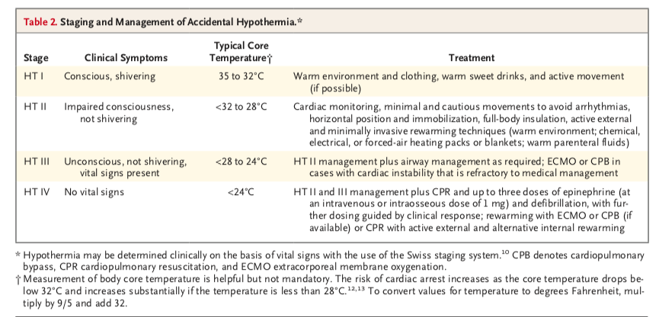

References

1. Brown, D. BC Accidental Hypothermia Working Group. (2016). Accidental Hypothermia - Evaluation, Triage and Management. Accidental Hypothermia Clinical Practice Guideline for British Columbia, Version 1.03.
2. Brown, D., Brugger, H., Boyd, J., & Paal, P. (2013). Accidental Hypothermia. The New England Journal of Medicine, (367), 1930–1938.
3. Dow et al. Wilderness Medical Society Clinical Practice Guidelines for the Out-of-Hospital Evaluation and Treatment
of Accidental Hypothermia: 2019 Update. Wilderness & Environmental Medicine. 30(4S): 47-69.

